Matter: Prosperities and Change Unit Plan

School System: Beijing Royal Foreign Language School

Grade Level: 2nd

Subject: Physics Science

Cooperating Teacher: Teacher Duan

**Part 1: Curriculum Map:**

The second grade science class that I am working with will begin a unit on the “Matter: Properties and Change”. The pacing guide recommends that 5days be utilized for instruction. This unit will specifically focus on NC Essential Standard **2.P.2**:

“Understand properties of solids and liquids and the changes they undergo.”

During the course of my 5days of instructional control of the classroom I will need to facilitate instruction that incorporates content associated with the statements of matter (solid, liquid, gas, molecular, water cycle, properties, and change). In each day of study, we’ll learn discipline based, to plan and do some experiments. Or by making hypothesis, test out the different statement of water. We will do the investigation about the molecular of the structure. What’s more, we will create our own website. Give examples of matter that change from a solid to a liquid and from a liquid to a solid by heating and cooling. Compare the amount (volume and weight) of water in a container before and after freezing. Compare what happens to water left in an open container over time as to water left in a closed container.

**Part 2: Pre-Test**

Test Framework:

|  |  |  |  |
| --- | --- | --- | --- |
| Content | Remember/Understand | Apply/Analyze | Evaluate/Create |
| **2.P.2.1**: solid, liquid, gas | 4 (1-4) | 1 (17) | 1 (18) |
| **2.P.2.1**: change of water by heating or cooling | 5 (5-9) | 1 (10) | 1 (23) |
| **2.P.2.2**: Compare the amount of water in a container before and after freezing | 3 (11-13) | 1 (16) | 1 (22) |
| **2. P.2.3:**  Compare what happens to water left in an open container over time as to water left in a closed container. | 1 (14) | 1 (15) | 1(24) |
| **2. P.2.3**: Compare other changes of solid or liquid or gas. | 2 (19-20) | 1 (21) | 1 (25) |

Unit Pretest

1. What is air?

A. solid

B.gas

C. liquid

2. What is milk?.

1. gas
2. liquid
3. solid

3._____ keep their size, but change their shape to fit the container they are in.

1. Gases

B. Solids

C. Liquids

4. What is a desk?

1. Gases

B. Solids

C. Liquids

5. The picture below most likely represents a _____.



1. Gases

B. Solids

C. Liquids

6. Vapor is a _____.

1. Gases

B. Solids

C. Liquids

7. _____ change their size and shape to fill the container they are in.

1. Gases

B. Solids

C. Liquids

8. The picture below most likely represents a _____.

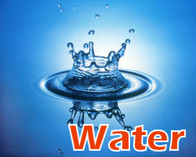

1. Liquid
2. Solid
3. Gas

9. Ice is a _____.

1. Liquid
2. Solid
3. Gas

10. Water going from a liquid to a solid is _____.

1. melting
2. condensing
3. freezing

11. _____ is anything that takes up space and has mass.

1. Matter
2. Volume
3. Condensation

12. Which of the following are states of matter? (Check all that apply.)

1. Gas
2. Mass
3. Solid
4. liquid

13. The amount of matter an object has is _____.

1. volume
2. evaporation
3. mass

14. Water in _____ will become less after a few days.  
  
 A B.

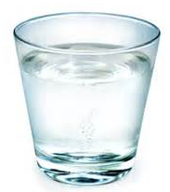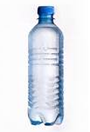

15. Water vapor that has turned into liquid water has gone through a process called _____.

1. evaporation
2. condensation
3. osmosis

16. Will the mass of water change after its freezing?____

A. Yes. B. No.

**17.**

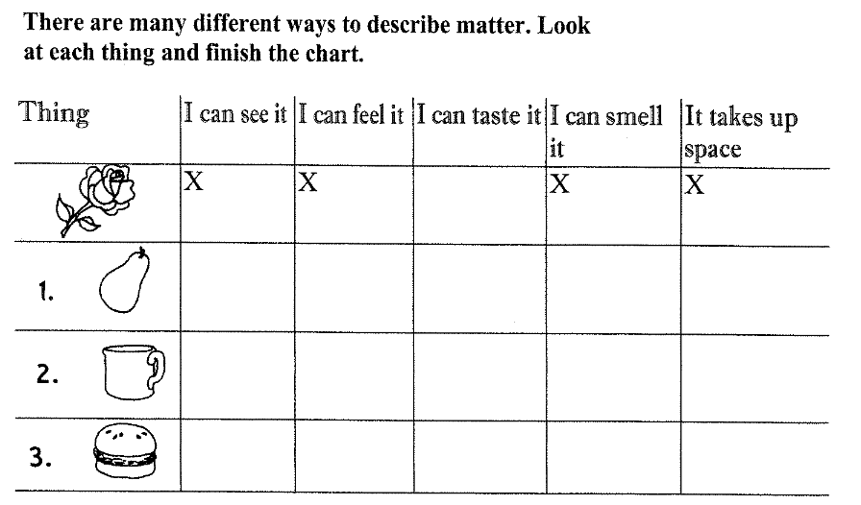

**18. Put the things into correct places.**

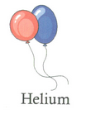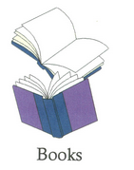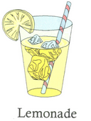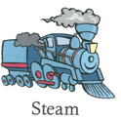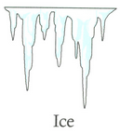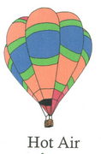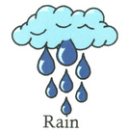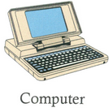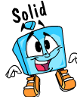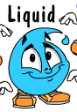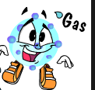

**Look at the things below.**

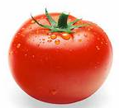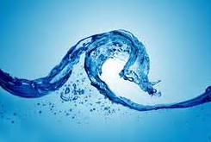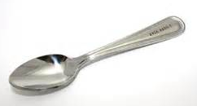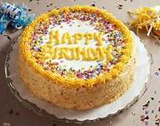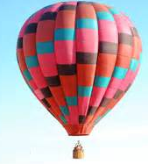

**19-20. Circle two things that you can cut into smaller pieces.**

**21. Draw a line under the thing that has gas inside of it.**

**Look at each picture below, and answer the questions.**

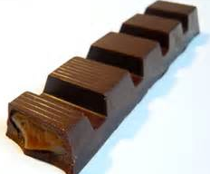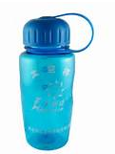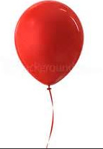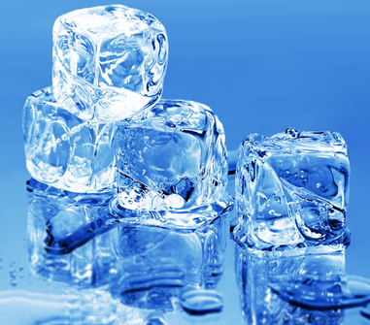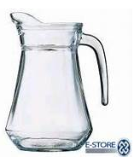

**22. Circle two things that can give water a shape.**

**23. Draw the water cycle by yourself**

**24. What changes to the water can you see after a few days? Why?**



**25. What can you find when you put a spoon of sugar in the water and mix them together?**

**Part 2: Pre-Test *Cont.* Reflection.**

1. These pre-tests are designed for potential to diagnose content area deficiencies and strengths. Students know well about the solid and liquid, because objects are visible. They have a little difficulty in recognizing gas. They need to do the experiment of different statements of water in home. They need to search more information about air. Some of them do not know the changes of statements and the mass of the objects.

**Part 3: Timeline, Scaffolding, and Objectives of Unit Lessons (5 days)**

Unit Outline:

* NCES: “Understand properties of solids and liquids and the changes they undergo.”
* Give examples of matter that is melting or freezing.
* Compare the amount (volume and weight) of water in a container before and after freezing.
* Compare what happens to water left in an open container over time as to water left in a closed container.
  + Essential Question: Can you name the states of matter?
* Big Ideas and Enduring Understandings :
  + Understand the properties of solids and liquids and the changes they undergo.
  + Compare the same material in different statements.
  + Touch things and name them states of matter.

Day 1

* NCES: 2.P.2.1: Name the states of matter and properties.
* Essential Question:
  + Can you name the states of matter?
* Objectives:
  + Upon the completion of this lesson the learner will understand states of matters and some properties.
  + Upon the completion of this lesson the learner will understand how to use tools to measure properties.
* Blooms Level: Remembering and Understanding
* Activities: Experiments, Videos, Smart Words

Day 2

* NCES: 2.P.2.1: Give examples of matter that change from a solid to a liquid and from a liquid to a solid by heating and cooling.
* Essential Question:
  + What will happen when the chocolate is heated? What will happen when heated chocolate cools down?
  + What properties have changed and what are not changed?
  + What about other things, such as water, sand, or metal?
* Objectives:
  + Upon the completion of this lesson the learner will understand heating and cooling can change the states of matter from solid to liquid, but not everything.
* Upon the completion of this lesson the learner will understand applicable vocabulary.
* Blooms Level: Remembering and Understanding
* Activities: Experiments, Discussions, Videos, Smart Words

Day 3

* NCES: 2.P.2.2: Compare the amount (volume and weight) of water in a container before and after freezing.
* Essential Question:
  + What is the volume of the water? What is the mass of it? (before and after freezing) Are there any changes to the volume and mass? Can you predict that?
  + How about heating water? How do you think the volume and mass change, why?
* Objectives:
  + Upon the completion of this lesson the learner will understand how the properties change or not.
* Blooms Level: Apply and Analyzing
* Activities: experiment, data recording.

Day 4

* NCES: 2.P.2.3: Compare what happens to water left in an open container over time as to water left in a closed container.
* Essential Question:
  + How the properties of water will change? (the same amount in the jar and a sealed bottle)
  + How about when the water gets heated? Can you predict the changes?
* Objectives:
  + Upon the completion of this lesson the learner will explain the changes of water in different containers.
  + Introduction of vapor and condensation.
* Blooms Level: Evaluate/ Create
* Activities: Experiment, Website, Make records and video.

Day 5

* Review and create own website
* Essential Questions:
  + How can we build our website with the states of matter?
* Objectives:
  + Upon the completion of this lesson the learner will search for information to build own website
  + Upon the completion of this lesson the learner will take a video and introduce the website.
* Blooms Level: All
* Activities: website and take video

**Part 4: Daily Lesson Plans**  (at the end of the assessment)

**Part 5: Unit Posttest or Summative Assessment**

Reflection: the students have more time to put hands on science, since they predict a lot, which is like to make hypothesis. They do more experiments, take data recording, and take video by themselves. They practice more to sense the science. They master better than the pre-test.

**Part 6: Reflection/Revision and Impact on Student Learning**

The experiments and the website makes the students more engaged in the class activities. Technology enriches the class in different forms. “Hands on science” is much more important than just knowledge. Although some kids are not good at learning, but their ability to do experiments is as good as others, which makes them more confident in the later class. They still need some assessment to comprehension more.

**Under level**: know solid, liquid, gas, change, can do experiments by themselves. They need to learn well in language and then science. They need to be encouraged and treated with more patience.

**On level**: they can tell properties of matters and different changes to water. They can do experiments and can tell the differences by sentences. They need do more science reading.

**Up level**: students can master the words and contents well. They can do experiments and find the reason why things happen and find more information about the matters, molecular and so on. They can design the experiment in their own way to explain changes to matters.

Class test is used to check the learning from the students. Most of the students do better in post test than in pre-test, except some who are in trouble in language arts learning. Such students need more time and patience from teachers. They will design their own experiment to observe the changes of water left in an open container over time as to water left in a closed container. They also create their own website. Student could use weebly to create their own website, so they were so excited to search for the information they needed to explain the words and phenomenon to others.

**Part 4: Daily Lesson Plans**

**Rubrics**

|  |  |  |  |  |  |
| --- | --- | --- | --- | --- | --- |
| Rubric (2 points) | Discipline & Safety Rules (2 points) | Interactive Learning (2 points) | Group work (2 points) | Website Building  (2 points) | Assessment (2 points) |
| Group One |  |  |  |  |  |
| Group Two |  |  |  |  |  |
| Group Three |  |  |  |  |  |
| Group Four |  |  |  |  |  |

I have divided the students into 4 groups, and there are five areas to judge their behaviors, Discipline and Safety Rules help the students have a good habit when they are in the class. Interactive learning means they need to ask and answers questions very actively; Group Work helps them to establish the sense of a team. They need to do some work together. Website Building enables them to find more interesting information to their own website. Assessment is a kind of means to help them to remember the contents they have learned. I will accumulate these rubrics to do portfolios.

**Day 1 LESSON PLAN**

**Concept/Topic(s): Three statements of matter**

* NCES: 2.P.2.1: Name the states of matter and properties.
* Essential Question:
  + Can you name the states of matter?
* Objectives:
  + Upon the completion of this lesson the learner will understand states of matters and some properties.
  + Upon the completion of this lesson the learner will understand how to use tools to measure properties.
* Blooms Level: Remembering and Understanding
* Activities: Experiments, Videos, Smart Words

**Background Information: The students learned living and non-living things already. They will take a pre-test before learn the statements of matter.**

**Materials/Resources:** (graduate cylinder, pan balance, containers like bottle, cup, plate, computers, work sheet.)

|  |  |  |
| --- | --- | --- |
| **Procedure:** | Teacher | Students |
| **Engagement:** | What can you see in our classroom? | Ss will talk about the things they see and the thing in balloon, including desk, water, plants, posters, air. |
| **Exploration:** | What is in the balloon? How about blowing it?  What is in the balloon?  Let’s put the things into three groups. | 1: desk, chair, book, board  2: water, milk, juice  3: balloon, plastic bag |
| **Explanation:** | Use Weebly to explain  Matter is everything around you.  A property describes how an object looks, feels, or acts. | Repeat the words and write on the smart cards. |
| **Elaboration:** | One property of all matter, whether it's a solid, liquid, or gas, is that it takes up space and has mass.  How can we measure the mass?  How can we measure the volume? | Use the pan balance to measure mass.  Use the graduate cylinder to measure the volume. |
| **Evaluation:** | If we put the same amount water in the fridge and a bottle, what will happen to the properties? | Think about the questions and make predictions. |

**Day 2 LESSON PLAN**

**Concept/Topic(s): The changes of water statements**

* NCES: 2.P.2.1: Give examples of matter that change from a solid to a liquid and from a liquid to a solid by heating and cooling.
* Essential Question:
  + What will happen when the chocolate is heated? What will happen when heated chocolate cools down?
  + What properties have changed and what are not changed?
* Objectives:
  + Upon the completion of this lesson the learner will understand heating and cooling can change the states of matter from solid to liquid, but not everything.

**Background Information: The students learned the statements of matter and some tools to measure them.**

**Rationale:** (Students should know the changes of statements of matter in a heating or cooling condition)

**Materials/Resources:** (alcohol burner, graduate cylinder, pan balance, chocolate, salt, sugar, work sheet.)

|  |  |  |
| --- | --- | --- |
| **Procedure:** | Teacher | Students |
| **Engagement:** | What’s this?  How will the properties change if we heat it? | Chocolate.  Predict |
| **Exploration:** | Divide students into groups.  Do the model. | Write down the data record. Mass and volume.  Heat the chocolate in a plate and measure the mass of chocolate. |
| **Explanation:** | No matter what kind of states changes, the mass will not change. | Write the data of mass. |
| **Elaboration:** | What will happen when we put the sugar into the water and stir them?  Do you think the sugar can continue dissolved?  How the properties will change? | Make hypothesis about the mass.  Find when dissolve enough sugar, the exact sugar will not be dissolved.  Record the data. |
| **Evaluation:** | Try to find if normal heating can change everything’s states, for example, the pencil, milk | Think about the questions and make predictions and observe with the help of parents. |

**Day 3 LESSON PLAN**

**Concept/Topic(s): The changes of water statements**

* NCES: 2.P.2.2: Compare the amount (volume and weight) of water in a container before and after freezing.
* Essential Question:
  + What is the volume of the water? What is the mass of it? (before and after freezing) Are there any changes to the volume and mass? Can you predict that?
  + How about heating water? How do you think the volume and mass change, why?
* Objectives:
  + Upon the completion of this lesson the learner will understand how the properties change or not.
* Blooms Level: Apply and Analyzing
* Activities: experiment, data recording.

**Background Information: The students learned the heating or after cooling can change the statements of some matters. .**

**Rationale:** (Students should know the changes of water in a heating or cooling condition and the change of volumes after freezing)

**Materials/Resources:** (graduate cylinder, ice box, pan balance.)

|  |  |  |
| --- | --- | --- |
| **Procedure:** | Teacher | Students |
| **Engagement:** | What’s this?  Now we put the water in fridge, what will happen to the properties? | Graduate Cylinder. Pan balance.  Predict about the volume. |
| **Exploration:** | Put the 100g water into a cube container, incase to calculate the volume. | Write down the data record. Mass and volume.  Discuss how to measure the volume or how the volume will change. |
| **Explanation:** | Write down the data of mass and volume. Calculate the volume of ice. Length*height*width.  The mass does not change. | Do the same thing as teacher and then compare about the volume and mass. |
| **Elaboration:** | What are the states of water?  What happened to the properties? | Draw some pictures of the changes to water. |
| **Evaluation:** | What will happen if we heat the water? How about in a jar or in a sealed bottle? | Think about the questions and make predictions. |

**Day 4 LESSON PLAN**

**Concept/Topic(s): Evaporation**

* NCES: 2.P.2.3: Compare what happens to water left in an open container over time as to water left in a closed container.
* Essential Question:
  + How the properties of water will change? (the same amount in the jar and a sealed bottle)
  + How about when the water gets heated? Can you predict the changes?
* Objectives:
  + Upon the completion of this lesson the learner will explain the changes of water in different containers.
  + Introduction of vapor and condensation.
* Blooms Level: Evaluate/ Create
* Activities: Experiment, Website, Make records and video.

**Background Information: The students learned freezing can change the statements of water.**

**Rationale:** (Students should know the changes of water in a heating or cooling condition and the change of volumes after freezing)

**Prior Knowledge/Connections:** (students know the statements of water and know heating or freezing can change the statement of water.)

**Materials/Resources:** (open mouth jar, sealed bottles, water.)

|  |  |  |
| --- | --- | --- |
| **Procedure:** | Teacher | Students |
| **Engagement:** | Review about last class.  Freezing can change the volume of water, how about heating? | Predict about the volume and mass.  Ask question about the containers.  Open or sealed. |
| **Exploration:** | Do the experiment.  Heat the water in an open mouth jar and a sealed bottle. | Write down the data record. Mass and volume.  Discuss how to measure the volume or how the volume will change. |
| **Explanation:** | Vapor:  Evaporation:  Condensation: | Draw the process of evaporation.  Draw some vapor. |
| **Elaboration:** | Which has the less mass? Why?  What else have the vapor? | The open mouth jar. Because of the evaporation.  Soup. Coffee. |
| **Evaluation:** | Do we drink the water thousand years ago? Why or why not? | Do research about water cycle. |

**Day 5 LESSON PLAN**

**Concept/Topic(s): Weebly website and presentation**

* Review and create own website
* Essential Questions:
  + How can we build our website with the states of matter?
* Objectives:
  + Upon the completion of this lesson the learner will search for information to build own website
  + Upon the completion of this lesson the learner will take a video and introduce the website.
* Blooms Level: All
* Activities: website and take video

**Background Information: The students learned the whole unit and need to do a unit closure.**

**Rationale:** (Students have known some knowledge of the statements of the simple matters)

**Prior Knowledge/Connections:** (students learn the knowledge and apple the contents to website)

**Materials/Resources:** (computers)

|  |  |  |
| --- | --- | --- |
| **Procedure:** | Teacher | Students |
| **Engagement:** | Have a review of concepts. | Output the concepts. |
| **Exploration:** | Today we’ll make our own website of matter.  What’s more, you need to take video about the process of making the website and introduce the website to us. | Write down the data record. Mass and volume.  Discuss how to measure the volume or how the volume will change. |
| **Explanation:** | Review how to build and add pages, how to choose themes. | Design the process . |
| **Elaboration:** | Help students who have problesm | Correct the mistakes and take videos. |
| **Evaluation:** | Do presentation. | Do presentation. |